BU-HIPERWALL USER’S MANUAL

# Start-up (Local)

Assuming that all the Hiperwall Display monitors are setup, running, and the Hiperwall Controller is running (see <<figure picture of Hiperwall waiting for information>>, follow these directions to “broadcast” or show what the user wants to display on the Hiperwall from their own monitors. See Figure 5. Display wall Screen Nomenclature and Figure 4. Desktop Monitor and Naming convention for help with nomenclature and the naming conventions used in this document.

1. Start Hiperwall by clicking on the Hiperwall Sender icon (Figure 1. Hiperwall Sender Icon)or desktop shortcut. The icon should be on the Windows taskbar at the bottom of the screen

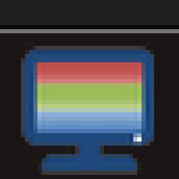.

Figure . Hiperwall Sender Icon

1. Wait a few seconds until the outer border of the Hiperwall Sender window turns green (See Figure 2. Hiperwall Sender Window.)
2. Click on Configure Sender Windows Button--the right most button--in the center of the Sender window.
3. Decide on how many monitors to project (called “***sending***”) see Figure 4 and how you want them displayed (Figure 5).

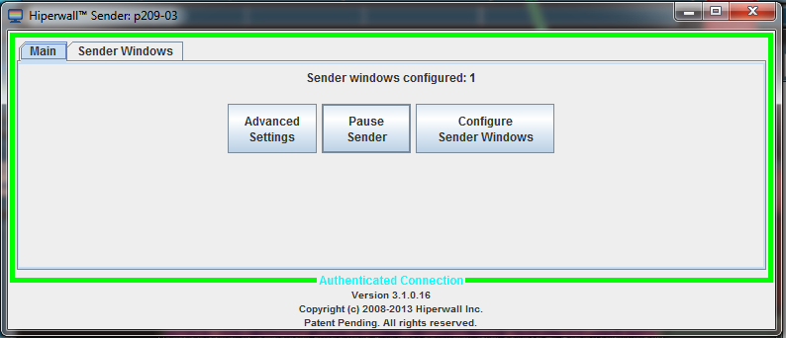

Figure . Hiperwall Sender Window

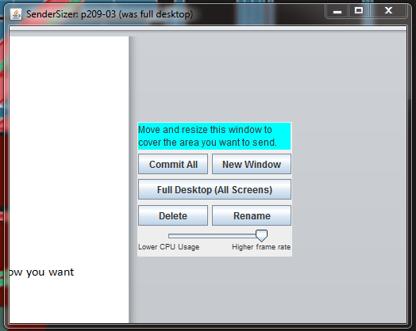

Figure . SenderSizer Window

### If you want to display all of your monitors…

*…choose on the Hiperwall SenderSizer* Full Desktop(All Screens)*. See*

Figure 3*. See* Sending All Monitors (Option LCR)

### If you want to display just one monitor…

*…move SenderSizer to the monitor you want to send and maximize the window, then click Commit All.*

### If you want to display two monitors or a custom area…

….Move SenderSizer to upper left of the area that you want to broadcast and click and drag bottom right corner to include the user’s chosen area.

## Displaying options

### Sending All Monitors (Option LCR)

4. Click Full Desktop (All Screens) on the SenderSizer Window (You will see the Hiperwall Sender Window on the Center Monitor (C).

5. Minimize the Hiperwall Sender Window.

6. Double Click P209-0# URL Explorer Shortcut on bottom Task bar.

7. Navigate to the Send All Windows Folder. Click on the Clear All Button

8. Chose option P209-0#-LCR.hwe (you will see the display on Hiperwall Display)

9. If you want to zoom in to fill the full Display wall, then click in the Zoom folder.

10. Click on the one of the three LCR zoom options as desired-

P209-0#-LCR-Zoom.hwe will zoom in the center display(C)

P209-0#-LCR-L.hwe will zoom the left monitor

11. If you want to zoom out and go back to your original mode, then click close.

12. Click on the p209-0# folder to go back to main menu

### OPTION CR:

13. Close the P209-0#.CR.hwe option (you will notice that the Display Wall is dark)

14. Display the Hiperwall Sender window and click on the Configure Sender Windows (then minimize the Hiperwall

Sender)

15. Move the SenderSizer Window to upper left hand corner of the center monitor and drag the bottom right hand

corner all the way to the bottom right hand corner of the Right monitor.

16. Double Click P209-0# URL Explorer Shortcut

17. Click on the Clear All Button

18. Chose option P209-0#-CR.hwe

19. If you want to zoom in to fill the full Display wall, then double click the P209-0# URL Explorer Shortcut

20. Click on the environments path and choose P209-0#-CR-Zoom.hwe

21. If you want to zoom out and go back to your original mode, then click close.

22. Click on the p209-0# folder to go back to main menu

*(The control head doesn’t know anything about what screens are being sent (that is… the environment might be ***labeled*** CR, but the control node doesn’t know or care if you are actually ***sending*** LCR), so the environment only requires that there is a computer with the same sender name sending. So, the naming conventions of LCR, CR,etc is ***only*** for human use…) *also note…* that if there is a sender name change, none of the url’s or environments will work… not the end of the world, just need to rename inside each of the environment variables…

*if using the url to control displays, there isn’t a screen asking to clear the display, so a lot of different screens can be broadcasting at the same time…

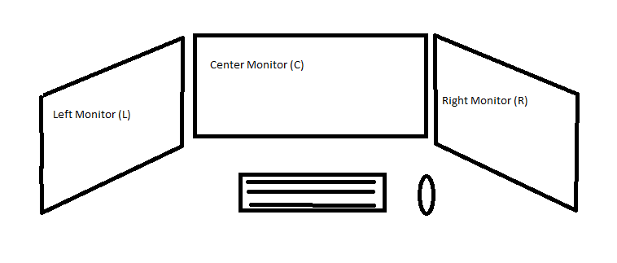

Figure . Desktop Monitor and Naming convention

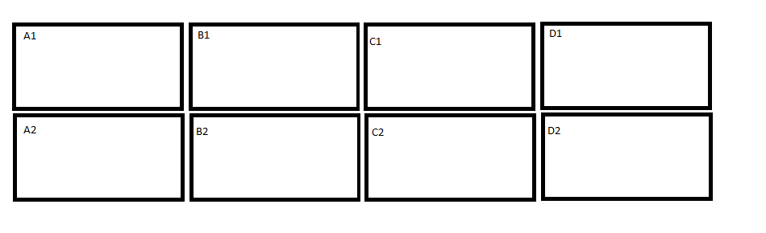

Figure . Display wall Screen Nomenclature

# To tile multiple web pages per screen and broadcast them on the Hiperwall

1. Open the browsers that you want up (I find that readability limits to 6 pages per desktop screen—I suggest to keep it to 4 per desktop screen

2. put them opened in small windows on the monitor that you want

3. open task manager (CTRL-ALT-DEL)

4. select all of the browser windows you want to tile in task manager applications tab and right click and select Tile Vertically…the windows should tile automatically the way you want

6. (Using method you prefer to control Hiperwall) Broadcast what you wanted from sender sizer and chose appropriate choice from url menus

# DaVinci instructions

On the desktop there should be an icon for the DaVinci-VisLab Audio Controlbelow. Double-clicking will bring upbelow the daVinci Audio Control. This is the way to control the audio capabilities of P209A. Audio is broadcast over traditional wiring to the amplifier in the bottom of the display node cabinet. The important thing to remember is that all the workstations broadcast their audio at the same time. What this means is that it can become a cacophony very quickly if workstations start playing audio at the same time.



Figure 6. daVinci Desktop Shortcut

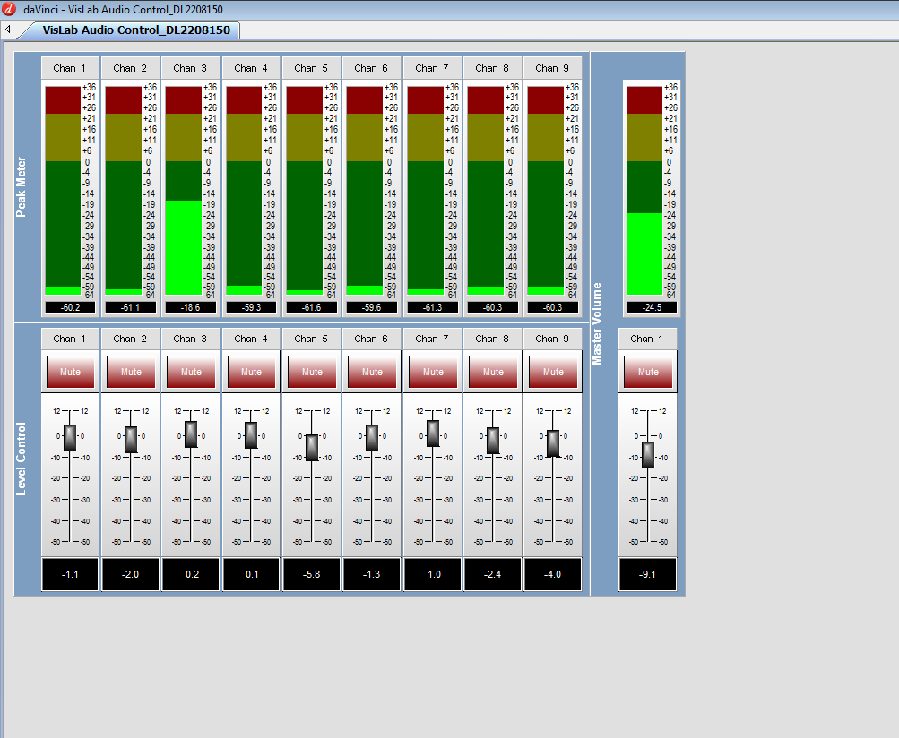

Figure 7. daVinci Audio Control

*to close after short cut to DaVinci is opened press <ctrl-F9> then close from x button in upper right corner

(x button might be highlightable, but will not work…) if <ctrl-F9> doesn’t work then try <alt-F9>